

**SIX WEEK SUMMER TRAINING REPORT**

On

( **WEB DEVELOPMENT)**

**Submitted by :Shubham Mishra**

**Registration no: 11715863**

**Programme Name: P132::B.tech(Computer Science & Engineering)**

Under the guidance of

**TEACH TECH SERVICES**

**SCHOOL COMPUTER SCIENCE AND ENGINEERING**

**LOVELY PROFESSIONAL UNIVERSITY, PHAGWARA**

**(**June-July , 2019)

**DECLARATION**

I hereby declare that I have completed my six weeks summer training at Teach Tech Services, LPU , from 10-06-2019 to 15-07-2019 under the guidance of Mr. Amit Pal. I have declare that I have worked with full dedication during these six weeks of training and my learning outcomes fulfill the requirements of training for the award of degree of Bachelors of Computer Science and Engineering, Lovely Professional University, Phagwara.

(Signature of Student)

Shubham Mishra

11715863

Date: 24-07-2019

**ACKNOWLEDGEMENT**

At the beginning I would like to thank to God who have given me the strength that I am able to learn this new technology and concepts in the scheduled time.

I wish to all who were there to support me unending. I would like to thank Mr. Amit Paul who was my supervisor in my training period. He always guided me to learn more skills. He polished my concepts and made me learn new ones.

I would like to thank Teach Tech Services who provided me the platform where I could learn the technology which I wanted to learn.

Moreover I am very grateful to Lovely Professional University, who have given me the best possible platform which a student can get. It has given us so many opportunities which act as real blessing in my life. Without it I would not be able to achieve what I have in my life.

I am very thankful to the faculty of Lovely Professional University who always supported and encouraged me to achieve my desired goals .

**TABLE OF CONTENT**

|  |  |  |
| --- | --- | --- |
| SNO | TITLE | PAGE |
| 1 | CERTIFICATE | 5 |
| 2 | INTRODUCTION | 6-20 |
| 3 | REASON FOR CHOSING THIS TECHNOLOGY | 21 |
| 4 | LEARNING OUTCOMES | 22-30 |
| 5 | **GANTT CHART** | 31 |
| 6 | BIBLIOGRAPHY | 32 |

**CERTIFICATE**



INTRODUCTION

I have done my six week training learning the technology named as “FULL STACK WEB DEVELOPMENT”. Full Stack means a person is “All ROUNDER” i.e person is able to handle front end , back end and data bases also.

I have chosen this technology to learn how we can make webpage look more attractive. I wanted to learn more about front end and back end technologies.

* Program a **browser** (like using JavaScript, jQuery, Angular, or Vue)
* Program a **server** (like using PHP, ASP, Python, or Node)
* Program a **database** (like using SQL, SQLite, or MongoDB)

**ADVANTAGES OF FULL STACK**

* You make be the master of all techniques involved in making project.
* You can reduce the cost of the project
* You can reduce the time used for team communication
* You can switch between front and back end development based on requirements
* You can better understand all aspects of new and upcoming technologies

You can make a prototype very

**DISADVANTAGES OF FULL STACK**

* The solution chosen can be wrong for the project
* The solution can generate a key person risk
* The solution chosen can be dependent on developer skills
* Being a full stack developer is increasingly complex

This six week summer training includes the technologies such as HTML,CSS and Javascript which are all front end technologies. It will make our website look more attractive. It will make other people taking interest in our website because of its appearance, outlook.

Moreover I have also learnt about Nodejs which is a back end language. It is called as Server side scripting language. I have also learn the concepts of MYSQL which is used to store data in the form of tables.

By these technologies we can make a website which will be liked by the people . We should make our front end look most attractive , then facilities and forms which are being used in it to make our website look amazing and different then others.

**TECHNOLOGY LEARNT**

In this summer training, the main technology learnt lies in the “full stack web development” domain. For this purpose, I chose to learn front end first of all which includes HTML,CSS And JAVASCRIPT.

**FRONT END WEB DEVELOPMENT:** It refers to the client side language. It is that part of the website which is visible to the public. It includes the languages as:

* HTML
* CSS
* JAVASCRIPT

**HTML:** This the first technology which I have learnt. HTML means Hyper Text Markup Language. It is the backbone of the web. Everything which is displayed on the website is written in HTML. It takes care of all the structure and content. HTML5 is the current iteration of HTML on the Web, although sites built with older versions still run fine in your browser.

HTML contains tags in it. It have 3 types of tag in this:

* **Container tag:** These are tags which have both opening and closing . Everything in tags is written with < > brackets. Example: <p> It is a paragraph tag which have both opening and closing i.e <p> and </p>. More examples are <body> and </body>, <html> and </html> , <font>and </font> etc.
* **Empty tag:** These are the tags which have only opening but no closing. Once it is opened no need to bother about it closing.

Example: <br> -It is the tag which is used to give line break.

<hr>- It is the tag which is used to display a horizontal line.

* **Comment tag:** It is the tag which is not displayed on the website . It is just used for the better understanding of the person who is reading the code which is written. Example:

**<!**-------------------------------------------------------------🡪

It is written as a comment. It will give extra information to the person who is reading the code.

Extension of html is .html and .htm. Anything without tag also written inside the notepad saved with the extension .html will be displayed on the webpage.

**STRUCTURE OF HTML WEBSITE**

<html>

<head><title> My first page </title></head>

<body>

</body>

</html>

Htnl page is divided in 2 sections i.e Head section and Body section. Ctrl+U is used to see the source code of the given website.

I have learnt various concepts in Html like:

* About different Heading tags i.e <h1> which will give me the largest heading. <h6> It will give smallest heading. If you will apply <h7> that will just give you data as a normal text.
* Tags like <marquee> , <strike> , <sub>,<sup>,<pre>.
* How to insert video, images, audio files in website
* Concept of list i.e ordered list and unordered list
* How to insert Hyperlinks
* Learnt about form which is a container tag i.e <form> and </form>.

It is <form name=”f1” method=”get”>. It can have 2 types in the method i.e Get and post method where get is the one which is used in the front end i.e given value by the user is seen while Post method deals with the backend.

* Concepts of Frame that it contains various concepts of how to insert the radio buttons, checkbox, select etc. Learnt about the buttons such as Submit, Reset and Button.
* In this I have learn about the concept of Tables which also have colspan and rowspan concept. It also have cell padding and cell spacing concept in it.

**CASCADING STYLE SHEET(CSS)**

This is the second technology which I have learnt inside the front end web development. It is called as CSS. It controls the way the HTML looks on the page. CSS sets the colors, fonts, background images, and even the way the page is laid out . We can use CSS to arrange the HTML elements on a page however you want, even if it’s different than the order they’re arranged in the HTML file. CSS3 is the current iteration of CSS on the Web, and adds a ton of features for things like basic interactivity and animations.

EXAMPLE: <h1>Hello</h1>

<p>This is a paragraph</p>

<h1>Byeee</h1>

When we want to give all headings a common style and all paragraphs common style this we use CSS. It saves our time a lot. We just have to give CSS and its design only once.

SYNTAX:

h1

{

Color:Red;

Font size:12px;

}

Here h1- Selector , color- It is the property and 12px is the Value which is assigned.

**TYPES OF CSS**

* **INLINE CSS:**  In this we will declare its styling at that time only which it is declared. An inline style may be used to apply a unique style for a single element.

Inline styles are defined within the "style" attribute.

EXAMPLE:

<h1 style="color:blue;margin-left:30px;">This is a heading</h1>

* **EXTERNAL CSS:** With an external style sheet, you can change the look of an entire website by changing just one file.Each page must include a reference to the external style sheet file inside the <link> element.

EXAMPLE: <head><link rel="stylesheet" type="text/css" href=”style.css”></head>

body {  
  background-color: lightblue;  
}  
  
h1 {  
  color: navy;  
  margin-left: 20px;  
}

This will be saved with style.css name.

* **INTERNAL CSS:** An internal style sheet may be used if one single page has a unique style.

EXAMPLE:

head>  
<style>  
body

{  
 background-color: linen;  
}  
  
h1

{  
 color: maroon;  
 margin-left: 40px;  
}   
</style>  
</head>

When we are using different paragraphs then if we want that different paragraphs should look differently then we will use the ‘id’ attribute inside that tag.

EXAMPLE:

<p id=”para1”>

Helloo

</p>

<p id=”para2”>

Byeeeee

</p>

Then when we will use ‘#’ in front of the id to tell the features.

#para1

{

Color:red;

Margin-left:50px;

}

#para2

{

Color:blue;

Margin-right:40px;

}

I have learnt that we can apply CSS in any of the tag which we want. It will make our website look in a better manner. Without CSS, HTML file will not look the way it is supposed to look like. It will make our website look more impressive.

**JAVASCRIPT**

Javascript is the third technology which I have learnt in my training period. It most commonly **used as** a client side scripting language. This means that **JavaScript** code is written into an HTML page. When a user requests an HTML page with **JavaScript** in it, the script is sent to the browser and it's up to the browser to do something with it.

It is light weighted, object based scripting language and cross plateform.

It is very useful to make our website look more technical and professional. As in form we can apply the javascript concepts so that person should always enter the valid details in the website.

Some of the works that can be done in javascript is that we can code in such a manner that person should always enter the phone number that is of 10 digits, password length much be fixed and by javascript we can also make our both the passwords get matched that if both matches then only it should proceed further. It makes our project look more professional.

ADVANTAGES OF JAVASCRIPT

* Here we can use alert in our website.
* We can do form validation with javascript.
* Client-side JavaScript is very fast because it can be run immediately within the client-side browser.
* It is simple to learn.
* Dynamic drop-down menus
* Displaying pop-up windows and dialog boxes (like an alert dialog box, confirm dialog box and prompt dialog box),

In HTML, JavaScript code must be inserted between <script> and </script> tags.

EXAMPLE:

<script>  
document.getElementById("demo").innerHTML =”Welcome";  
</script>

Here Javascript have various possibilities to display content on the screen such as:

* Writing into an HTML element, using innerHTML.
* Writing into the HTML output using document.write().
* Writing into an alert box, using window.alert().
* Writing into the browser console, using console.log().

**2 FORMS IN WHICH WE CAN USE JAVASCRIPT**

* **INTERNAL JAVASCRIPT :** In this we can apply and use javascript just by having <Script> tag in our program. In that tag we can write javascript code.

Here we can put <style> tag anywhere inside our code that is :

* + Inside Head tag
  + Between the Body tag

**EXAMPLE:**

<html>

<head>

<script type=”text/javascript”>

Function msg ( )

{

Alert(“Hello java”);

}

</script>

</head>

<body>

<p>Welcome to the world </p>

<form>

<input type=”button” value=”click” onclick=”msg()”>

</form>

</body>

</html>

* **EXTERNAL JAVASCRIPT :** Here we will make a file which will be saved with .js extension . It provides **code re usability** because single JavaScript file can be used in several html pages.

**EXAMPLE:**

Function msg()

{

Alert(“ Hello World”);

}

Will save this will file.js extension. Now will code for HTML page .

<html>

<head>

<script type="text/javascript" src="file.js"></script>

</head>

<body>

<p>Welcome to JavaScript</p>

<form>

<input type="button" value="click" onclick="msg()"/>

</form>

</body>

</html>

This is the way can have external Javascript in our code.

**NODE JS**

This is the fourth technology which I have learnt in my training period. I took time in learning this technology still I will work hard to learn more about it.

* It is a server side scripting language
* It is javascript based
* Open souce
* Single threaded

**Node**.js is based on V8 engine developed for Chrome browser by Google corporation, as a framework for javascript execution. But now there is a possibility to log program work into file, that puts **Node**.js on par with other **technology** that allow to develop executable applications.

* Node.js uses an event driven
* Non blocking model
* Light weighted
* Efficient
* No buffering

First of all we have to install node.js. After that we have to set the path here.

**EXAMPLE:**

Console.log(“hello”);

Will save this file with first.js. Now will do the HTML code.

**NODE.JS HAVE 3 PARTS**

* **Import a required module**- It is done by using a “require” directive.
* **Create a server-** You have to establish a server which will listen to client's request similar to Apache HTTP Server.
* **Read request and return response:** Server created in the second step will read HTTP request made by client which can be a browser or console and return the response.

EXAMPLE :

Var http= require(‘http’); // This is used to require module in our system.

http.createServer(function(request,response)

{

Response.writeHead(200, {‘Content-Type’: ‘text/plain’});

Response.end(“Hello World”);

}).listen(4000);

Console.log(‘Server running at <http://127.0.0.1:4000/>');

Now save this with node.js command. After that we will open node command prompt.

**COMMAND USED:**

Cd desktop

Cd nodejs

Node node.js

**OUTPUT:**

‘Server running at <http://127.0.0.1:4000/>

**WEB BROWSER:**

When we will copy this link and write into browser then message will be displayed as :

Hello World

By this we can be connected to server side. By using Node.js we can do so.

**NPM ( Node.js Package Manager)**

**NPM** will provide all the modules that are being required in our node.js . It is basically used to install and get the various modules which are being required.

**CODE:** npm version

Npm install express // It will install the express module and a folder will be made

Npm uninstall express //It wil uninstall the module express

Npm search express //It will search for express module

**CALL BY FUNCTION**

It consists of CALL BY FUNCTION is a function passed in another function as an argument which is invoked inside the outer function to compute some routine or action.

EXAMPLE: Function Demo( )

{

document.write(“Hello”);

}

Function Show( )

{

Document.write(“Bye”);

}

Function display(Show)

{

Show();

}

Display(Demo);

}

**MYSQL**

This is the fifth technology which I have learnt in my six week training period. It is basically used for database connectivity. MySQL is a relational database management system. It is open-source and free.

* MySQL is quicker than other databases so it can work well even with the large data set.
* MySQL uses a standard form of the well-known SQL data language.
* It is used to store data in form of databases.
* MySQL is a very powerful program so it can handle a large set of functionality of the most expensive and powerful database packages.
* It is easy to use and scalable.

We should install Mysql in our system so that we can start working with this.

* We can create database by the command : create DATABASE database_name;
* To see that it is created or not : show DATABASES;
* To use the specific database : use database_name;
* To drop the database : d rop DATABASE database_name;

It basically consist of databases so we can store it can form of table. So I came to learn that how I can use table to store data which further can be used.

**CODE TO CREATE TABLE:**

Create table student

{

Name varchar(100) NOT NULL; // Cannot be empty

Admno Number ;

Marks Number;

PRIMARY KEY admno; // primary key= Not null+unique

}

**TO SHOW TABLE :** show tables;

**HOW TO MAKE DATABASE CONNECTIVITY:**

var con=mysql.createConnection(

{

host:"localhost",

user:"root",

password:"",

database:"look" // Database is made with look name.

**})**

con.connect(function(err)

{

if (err) throw err;

console.log("connected"); //It will be printed on terminal

});

**EXPRESS JS**

Express Js is the another technology which I have learnt in my training. Express.js is a web framework for Node.js. It is a fast, robust and asynchronous in nature. It can have some of the facilities which we can have:

* It can be used to design single-page, multi-page and hybrid web applications.
* It allows to setup middlewares to respond to HTTP Requests.
* Ultra fast I/O
* Robust API makes routing easy
* It is asynchronous in nature

Way by which we can use Express js is:

Var express=require(‘express’);

Var app=express();

app.get('/', function (req, res) {

res.send('Welcome to JavaTpoint!');

});

var server = app.listen(8000, function () {

var host = server.address().address;

var port = server.address().port;

console.log('Example app listening at http://%s:%s', host, port);

});

We use npm install express to install express module in our system.

**REASON FOR CHOSING THIS TECHNOLOGY**

I have chosen this technology because I really wanted to learn how we can make a website and wanted to learn the working of it. I have seen many students are getting placed in this field that made my mind towards this course. Not only the students by also my interest that made me learn this technology.

It is a problem solving . It has a wide range and it is cost effective also. I really wanted to learn that how we can maintain a website in a better manner. It will increase our management skills also.

Now a days number of companies want a full stack developer that is considered to “ALL ROUNDER” in the work. I wanted to learn front end first of all that how our website will look like. It has a good career choice. For that I decided to learn HTML,CSS and JAVASCRIPT.

I wanted to learn even about the back end language so I have chosen Nodejs and for database I have chosen MYSQL.

* For placement purpose
* I really wanted to learn how we can manage the website
* Wanted to learn front end, back end , databases
* By learning and giving my more efforts towards this I can even open my own startup
* Huge demand of full stack developers
* Diversified Job opportunities
* It is flexible
* Cost effective
* Hired by the best Employees
* Want to learn the management skills by managing and working over the website
* Growth Prospects
* Easy to learn

These are the various reasons that made me learnt this technology and I really wanted to be professional in this field. I am looking forward towards placement and job in this field. I really wanted to be an All rounder.

Being a full stack developer is a great responsibility and to be that I have to learn more and more about it .With my practice and dedication towards this work will make me successful in this field.

**LEARNING OUTCOMES**

From this six week training I have got a very meaningful experience that how I can deal with front end , back end and databases.

In front end I have learnt the concepts of HTML,CSS and JAVASCRIPT. I have also coded it while learning. I have also practiced a website using these concepts. I have worked with the Front End language.

**EXTERNAL CSS , <DIV>,<ul>**

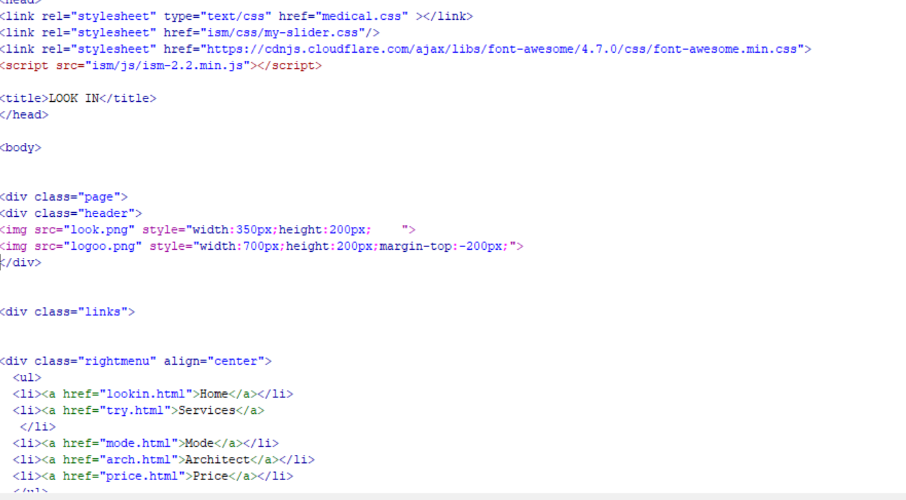

* In this I have learnt that how we can use external CSS in our code. As inside <head> tag we have <link> tag which is further showing the reference of CSS named as medical.css. It is showing the external CSS.
* Here I have also used the concepts of <div> which is also called as a block tag which will divide my html page into various blocks that can be further used to apply CSS in my website.
* I have used <ul> tag which is called as unordered list which further contains <li> tag inside it which means list item.
* <a> is an anchor tag which is used to give links in our website. <a href=”lookin.html”> , it means which we will click at Home then it will open lookin.html page. It is acting like a reference to another page.

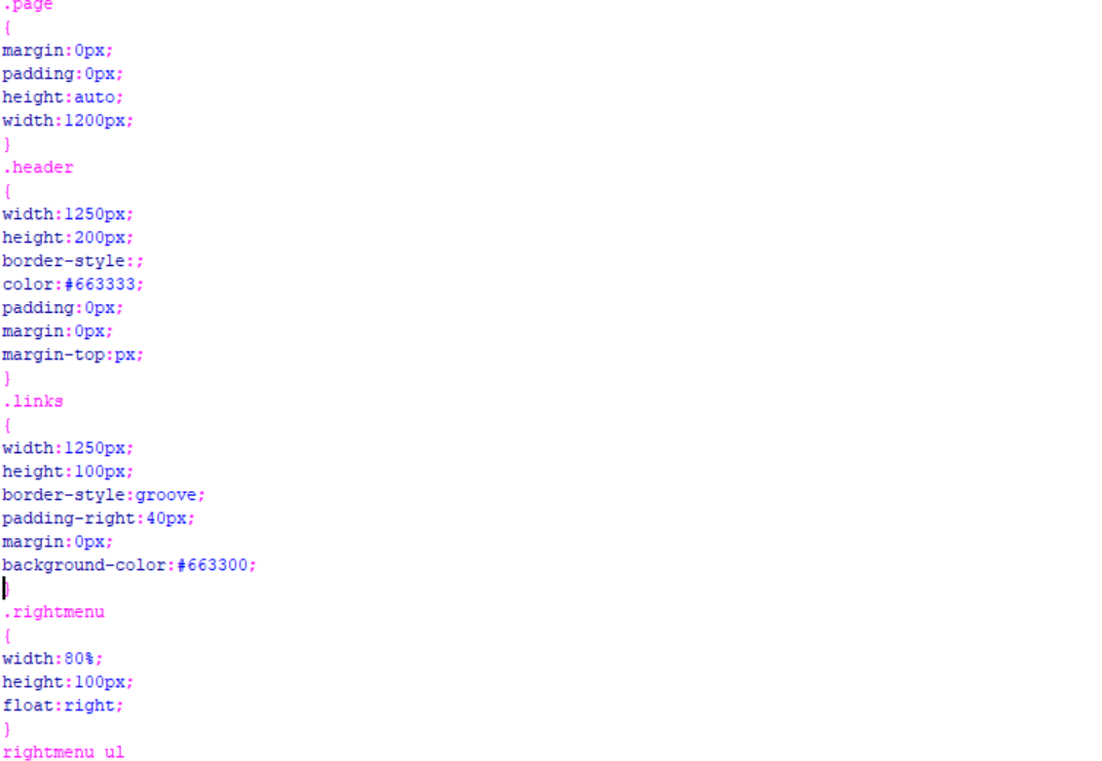

This is medical.css i.e External CSS which I have used. In this I have given the values of every <div> , <a> tag and many more. This will make my website look in a better manner. It will make it look more impressive and attractive.

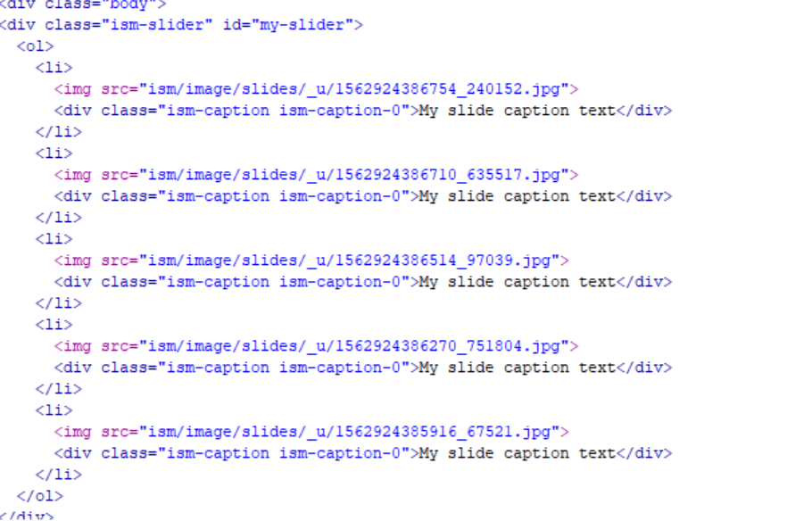

In this code I have tried to add slider in my website. I have made 5-6 pictures slider in this which will make my website look more professional. I have used an online slider maker in which I can make the slider of the images. After that a file will get open which will have code in it which the specific instruction in it that where to copy the code. In this way I have inserted an slider in my webpage.

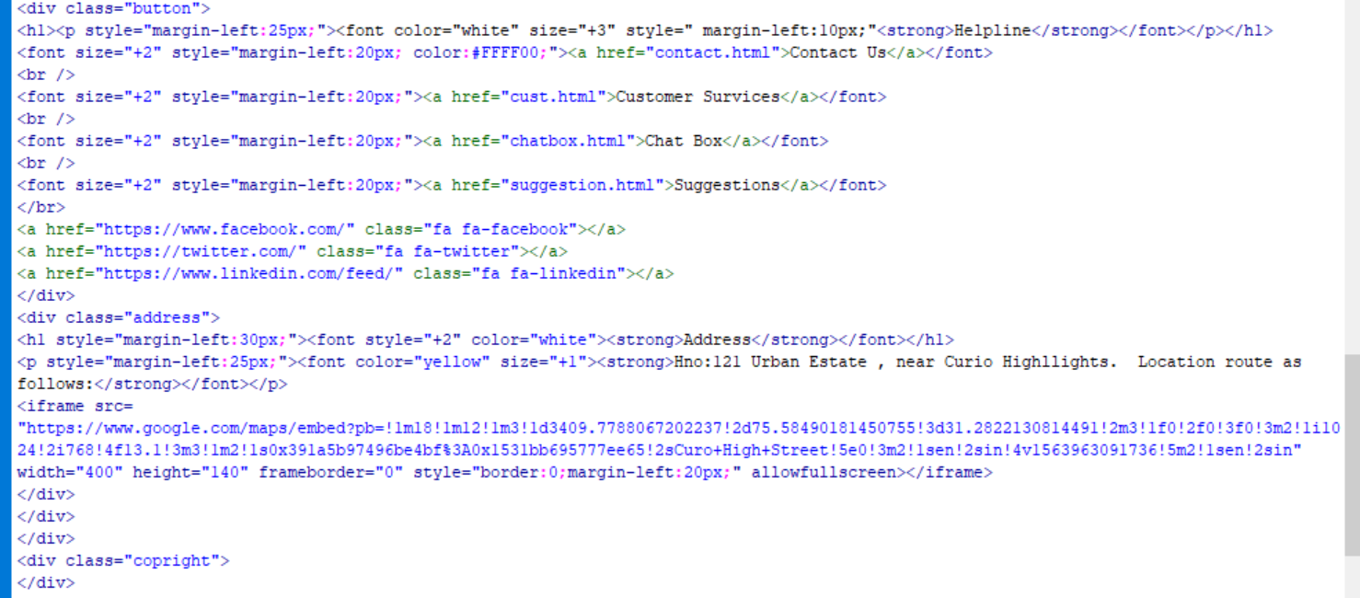

* In this I have used the <div> tag named as <div name=”button” which is further mentioned in medical.css which will give all the necessary designs which are required.
* In this I tried to insert the icons such as Facebook, twitter, linkedin and I have given the specific link when we will click at that button.
* It this I have made another class <div name=”Address”> in which I have tried to add the live location . For that first of all I have opened the Google Maps – Options- Shared and Embedded Maps- copy the <iframe src=” --”> from there. After that paste it in the webpage where you want that live location to be inserted.

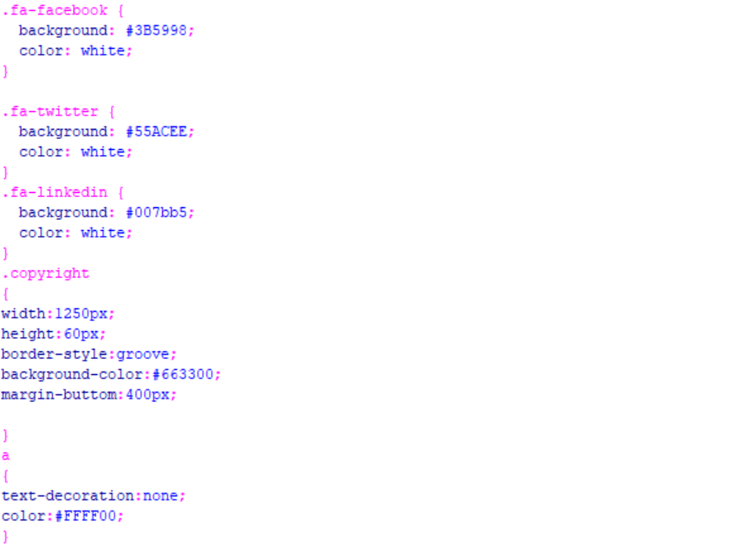

This is the CSS which I have used to make my buttons to look in proper manner. It is very important to give CSS which it. It will give icon the

original look how it is supposed to look like.

**LEARNT HOW TO MAKE IMAGE GALLERY**

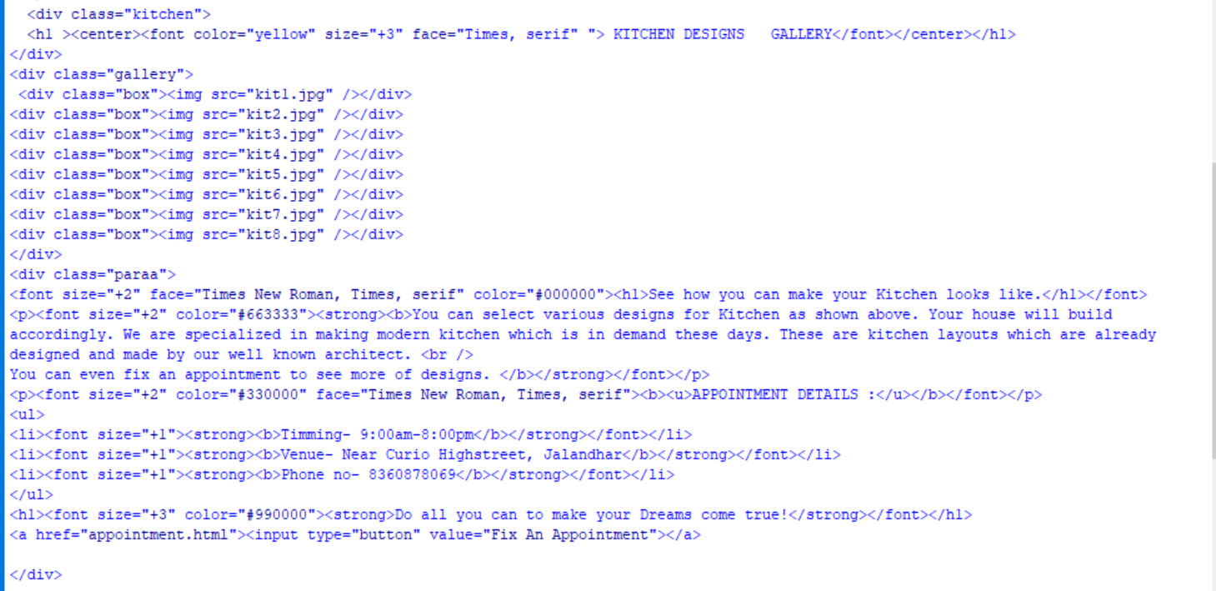

It is just the simple HTML code in which we are making an image gallery which is incomplete without its CSS as CSS will add extra features and effects to our HtML page.

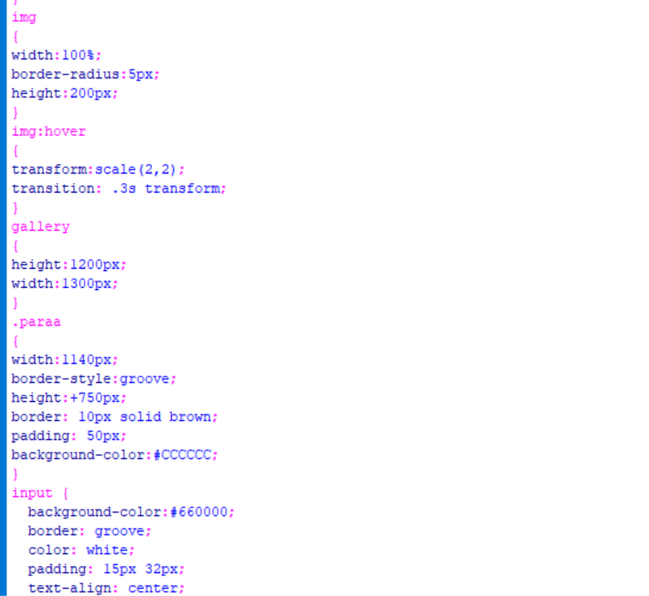

* This is the CSS code which is given by which our gallery would not look like gallery. In this I have used Border-radius:5px; which means we will make it curve from all the 4 sides.
* In this I have set full dimensions of the <div name=”gallery”.
* In this used the img:hover which is used to make our image enlarge inside which will come outer with the above mentioned scale (2,2) which means from X-axis it should be 2 and same with the Y-axis also.

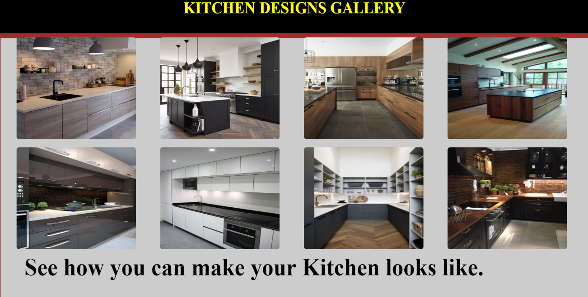

This gallery will look like this. When ever we will click on the desired image then after that it will come out and will get enlarge .

**LEARNT HOW TO MAKE CHATBOX**

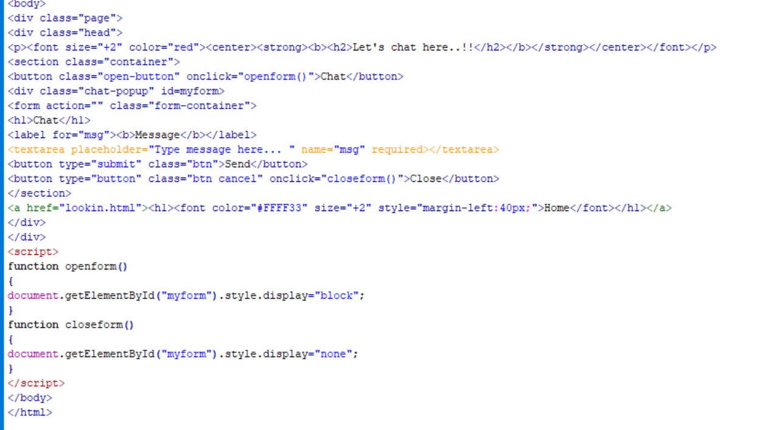

* This is the code which is used to make a chat box. It is the HTML code of the given page. In this I have used the concept of javascript in which I have used the <textarea> in which we can write the text and that will act like a chat box where we will write the message.
* Here when we will click on the Cancel button then ‘closeform’ will be opened.
* Javascript is always written inside the <Script> tag which can be placed inside the <head> tag or inside the <body> tag.

**FORM VALIDATION**

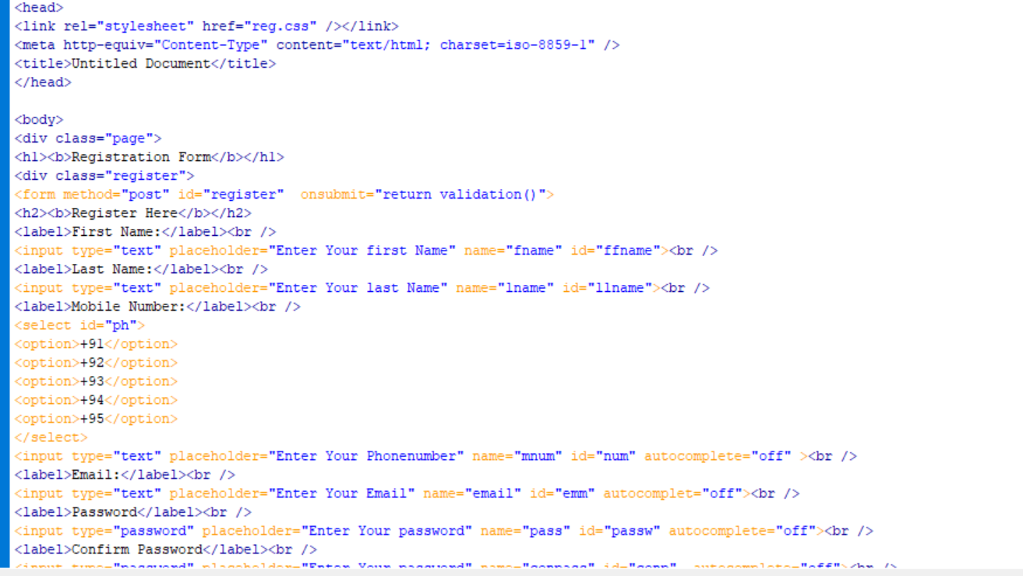

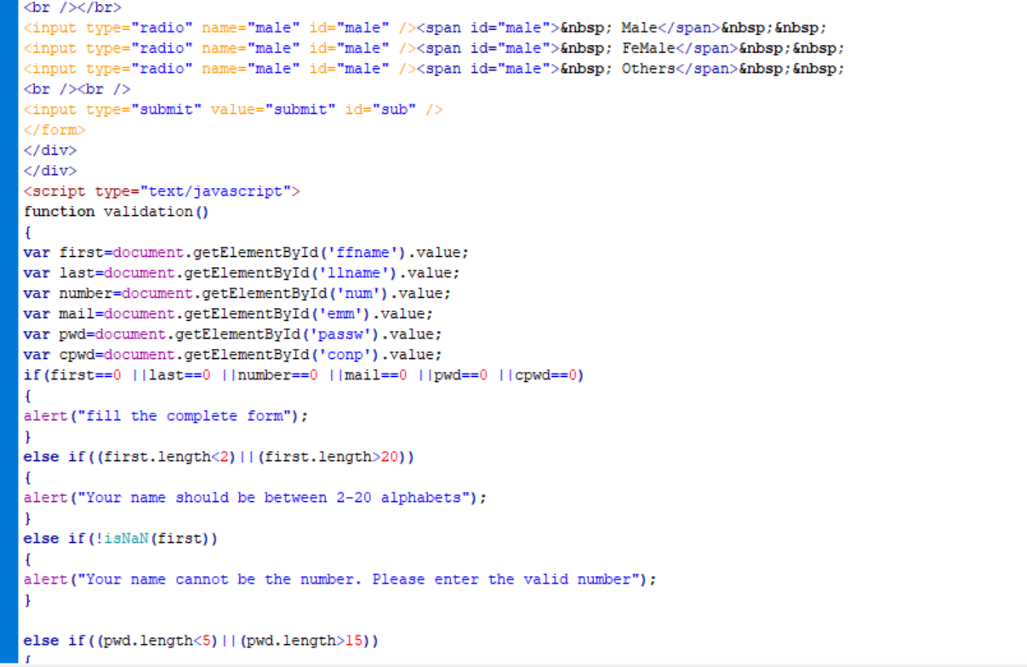

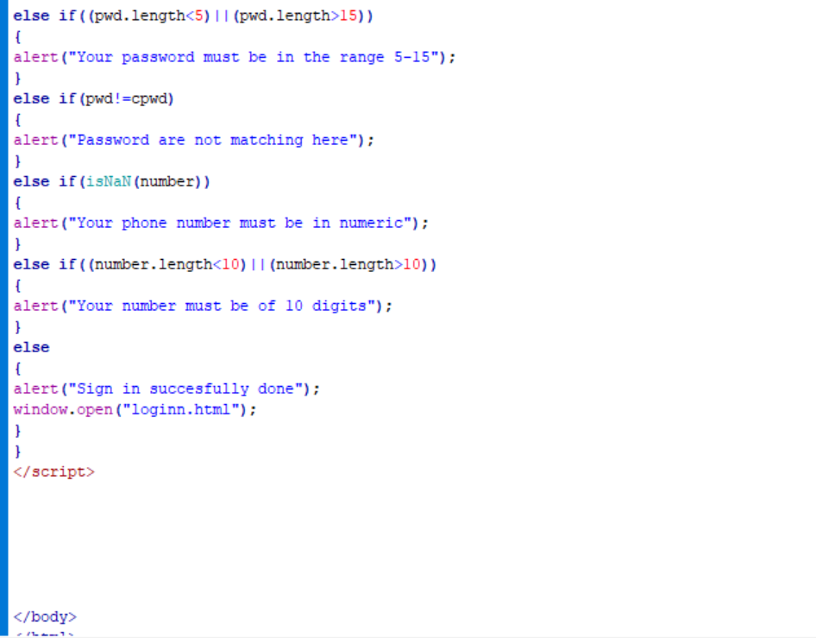

* In this form I have learnt so many new concepts such as how I can make a <form>
* When we want to take input in the form then we use <input> tag in this which have various input type in it . As when we want to take input as name then we will have

<input type=”text”>. When we want to take input as password then we will use

<input type=”password”>. When we want to take input as Email then we will use

<input type=”Email”>.

* Here when we will click on Submit button then it will open a function named as

Validation().

* In this we write document.getElementId(‘ffname’).value where ffname is the id which is given to the name label and so on to all. Everyone will have different id in this .
* In this form validation I have used javascript and this it will display alert( ) message where ever it is required.
* It will display message as an alert “Please fill the form” when we will not fill the form completely then alert will be there.
* By this we can specific the length of the password that our password should be between this length only.
* Afterwards we can match both the passwords that it is correct or not. If both passwords matches then only another action will be performed otherwise again alert message will be displayed.
* In this we have also applied the condition in the form that our number must be of 10 digits , it should not be less then 10 nor greater then 10. If it /
* happens then alert(“Please Enter the Valid Number”) message must be displayed.
* If everything satisfies and your form is filled fully then it should be successfully Signup and alert(“Successfully done”) must be on your screen . After that a new page should be displayed.

**PORTFOLIO OF WELL-KNOWN PERSONALITY**

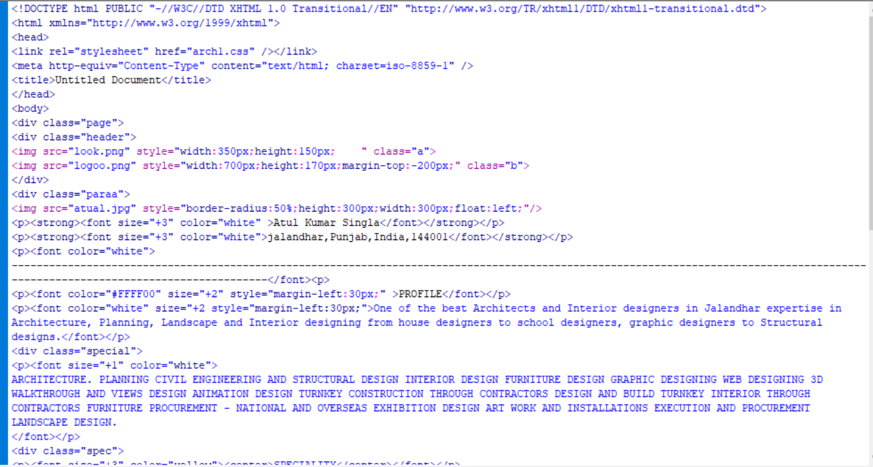

* In this I have made a portfolio of the well known Architect. In this I have used the concepts of <div> , <img>, <font> and so on.
* To make this portfolio look in a better manner for that we will use CSS.

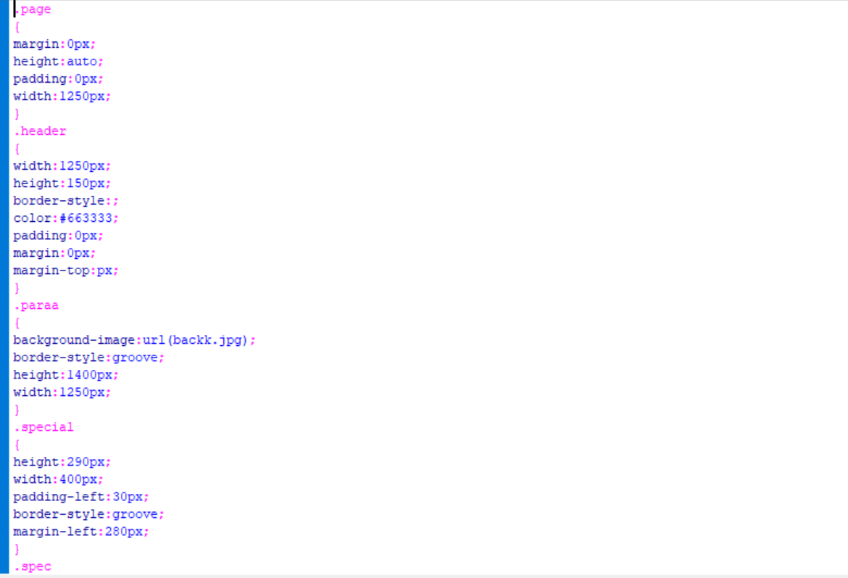

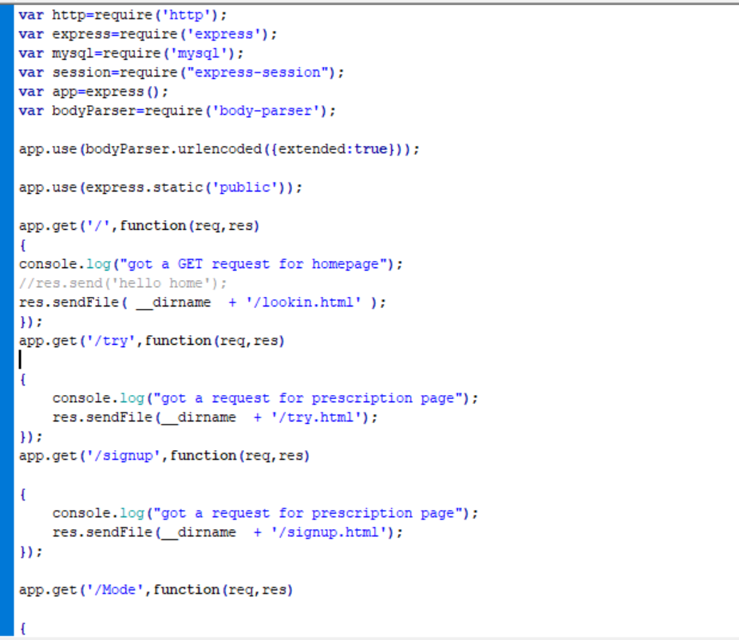

In the above code I have done the connection to the server. In this I have connected all my webpages to the local Host.

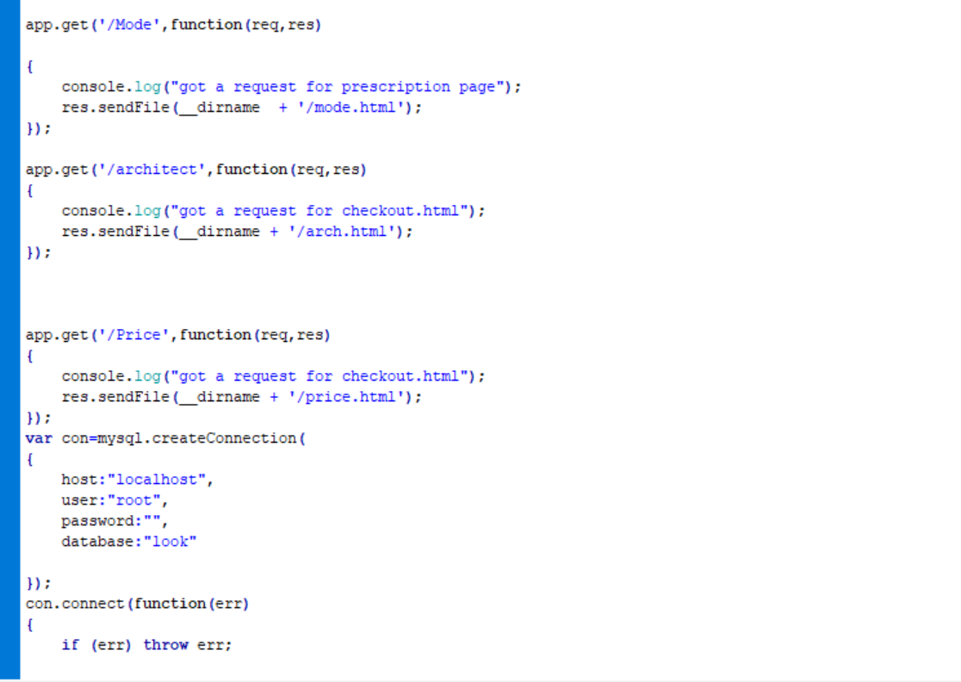

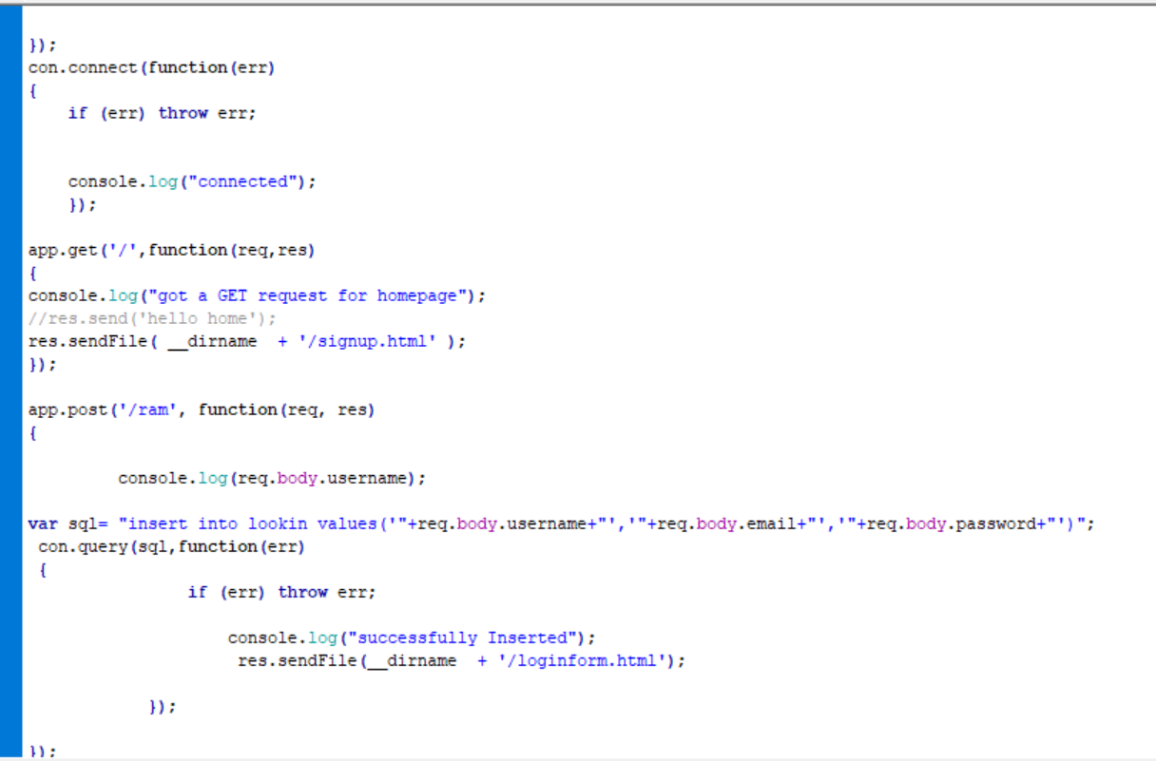

* In this I have learnt the various concepts of Mysql, that we can insert the values into the table.
* In this console.log( ) means anything that will be displayed on the terminal.
* Here app.post means it will work at the server end.

**GANTT CHART**

**BIBLIOGRAPHY**

* I have done my training from teach tech services.
* I have taken help from [www.youtube.com](http://www.youtube.com)
* I have also taken guidance from javaTpoint , w3 School
* Some idea was also taken from [www.Beautifulhouse.com](http://www.Beautifulhouse.com)
* Stack Overflow
* Github
* [www.google.com](http://www.google.com)